LAB REPORT OF

Artificial Intelligence

(ADBB 205)

A report submitted in partial fulfillment of the requirements for the award of the degree of

BACHELOR OF TECHNOLOGY

IN

ARTIFICIAL INTELLIGENCE AND DATA SCIENCE

Submitted By

Abul Hasan (231212002)

Submitted To

Dr. Sahil



DEPARTMENT OF COMPUTER SCIENCE AND ENGINEERING

NATIONAL INSTITUTE OF TECHNOLOGY DELHI

DECEMBER 2024

DDA line

DDA triangle

DDA circle

Mid Point Circle Generation -single circle

Mid Point Circle generation- Olympics logo

Mid Point Circle generation – Audi logo

Animation of moving a car left to right along with smoke

Boundary Fill Algorithm

4-connected points

8-connected points

Straight fill

Diagonal Fill

Flood Fill Algorithm

DDA Algorithm (Line)

Code:

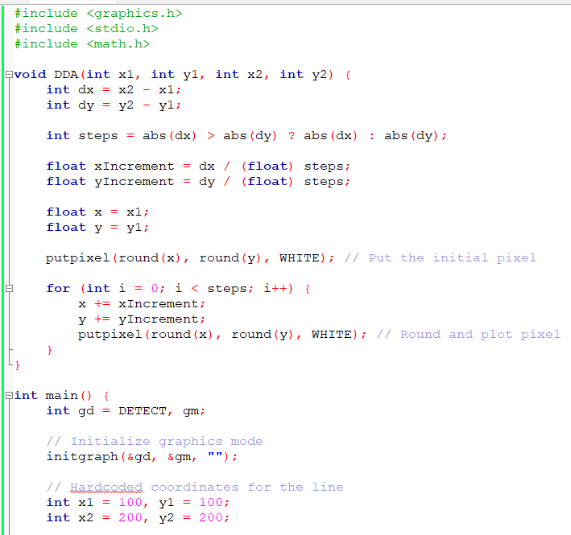

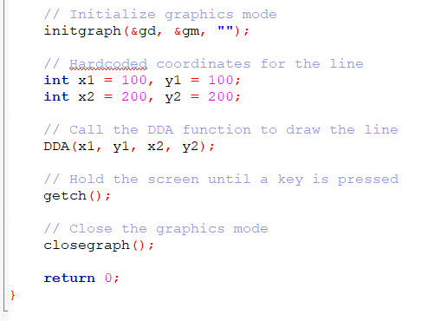

Output:

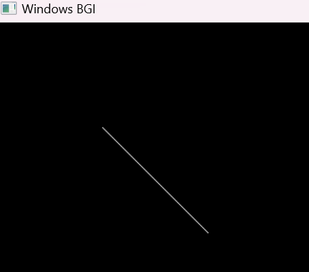

DDA (Triangle)

Code:

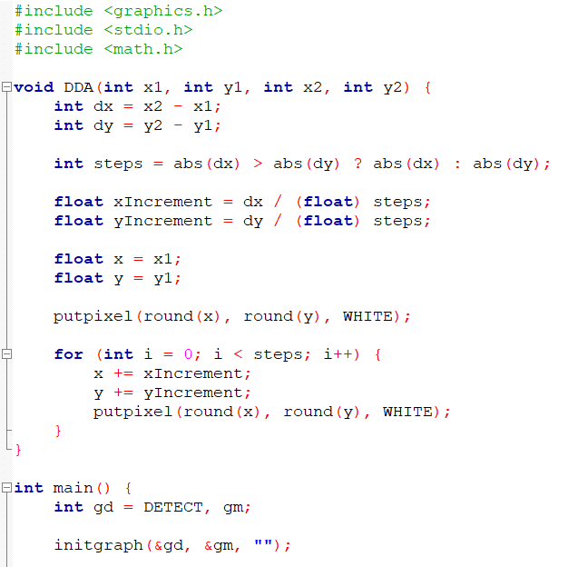

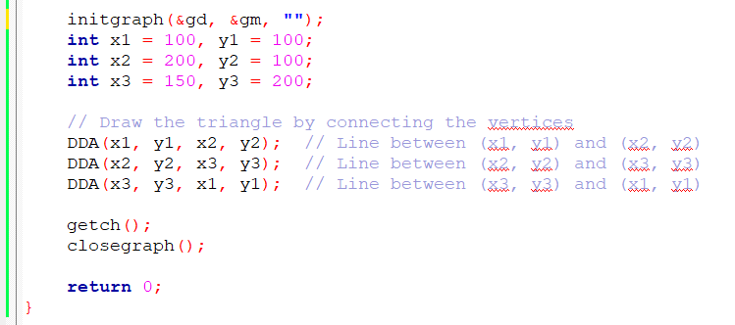

Output:

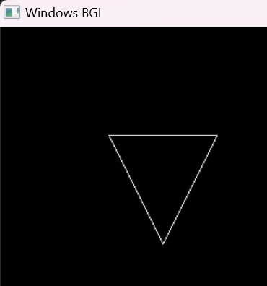

DDA(Rectangle)

Code:

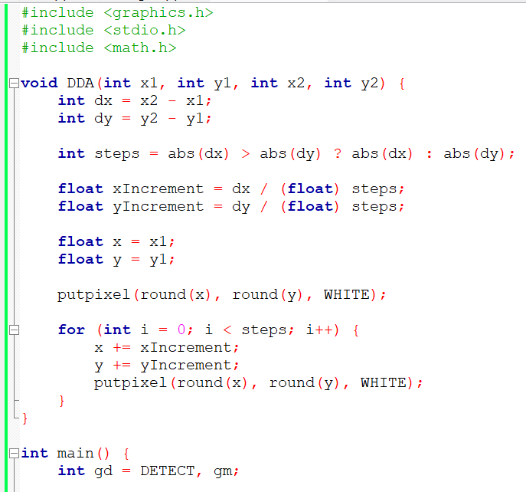

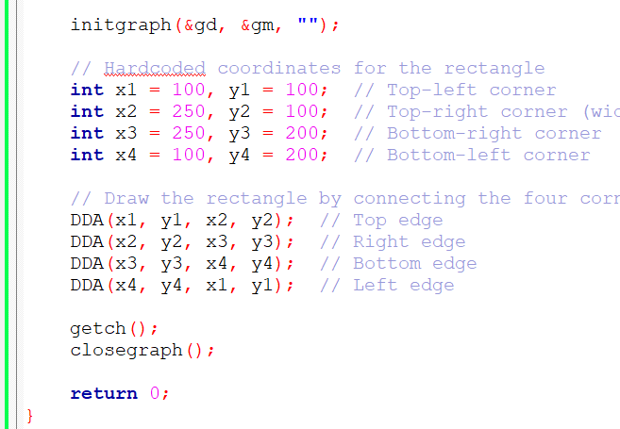

Output:

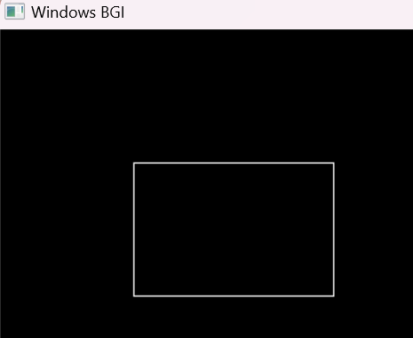

Mid-Point Circle Generation – Single Circle

Code:

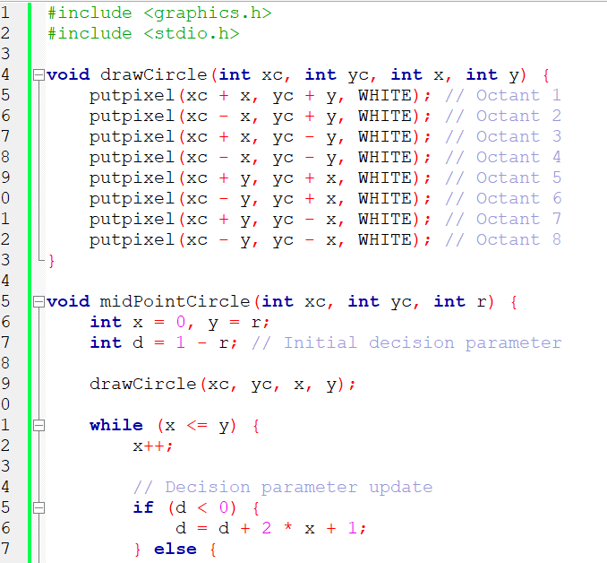

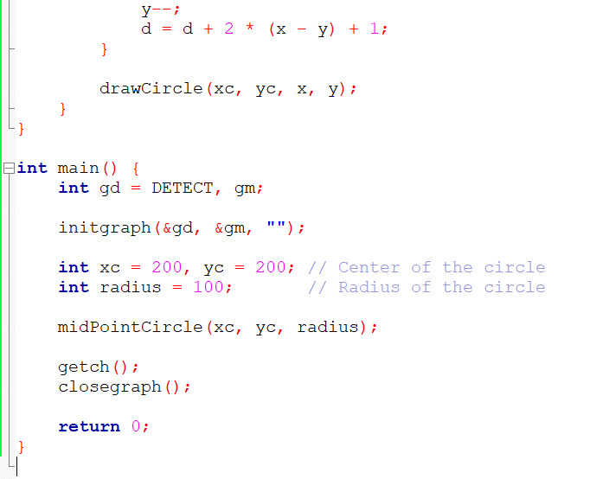

Output:



Olympics Logo

Code:

Output:

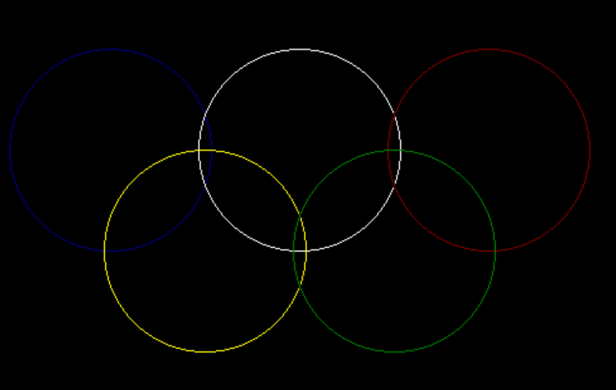

Audi Logo

Code

Output

